1. Install Power BI Desktop and share the final screenshot of the report view page which appears when power desktop starts.

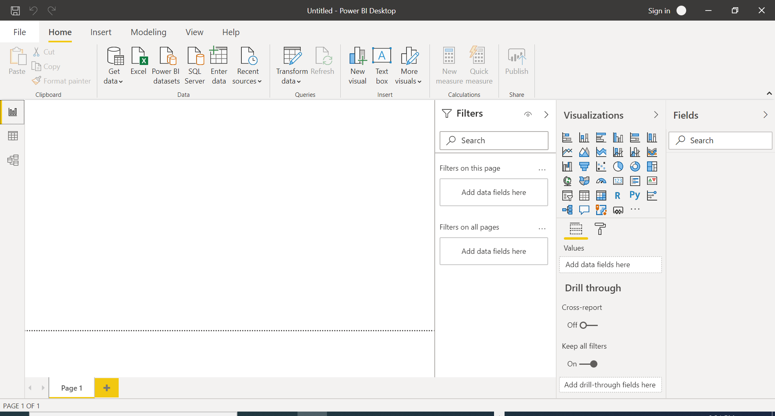

1. Prepare a document and with the following screenshot:

* Report View



* Data View

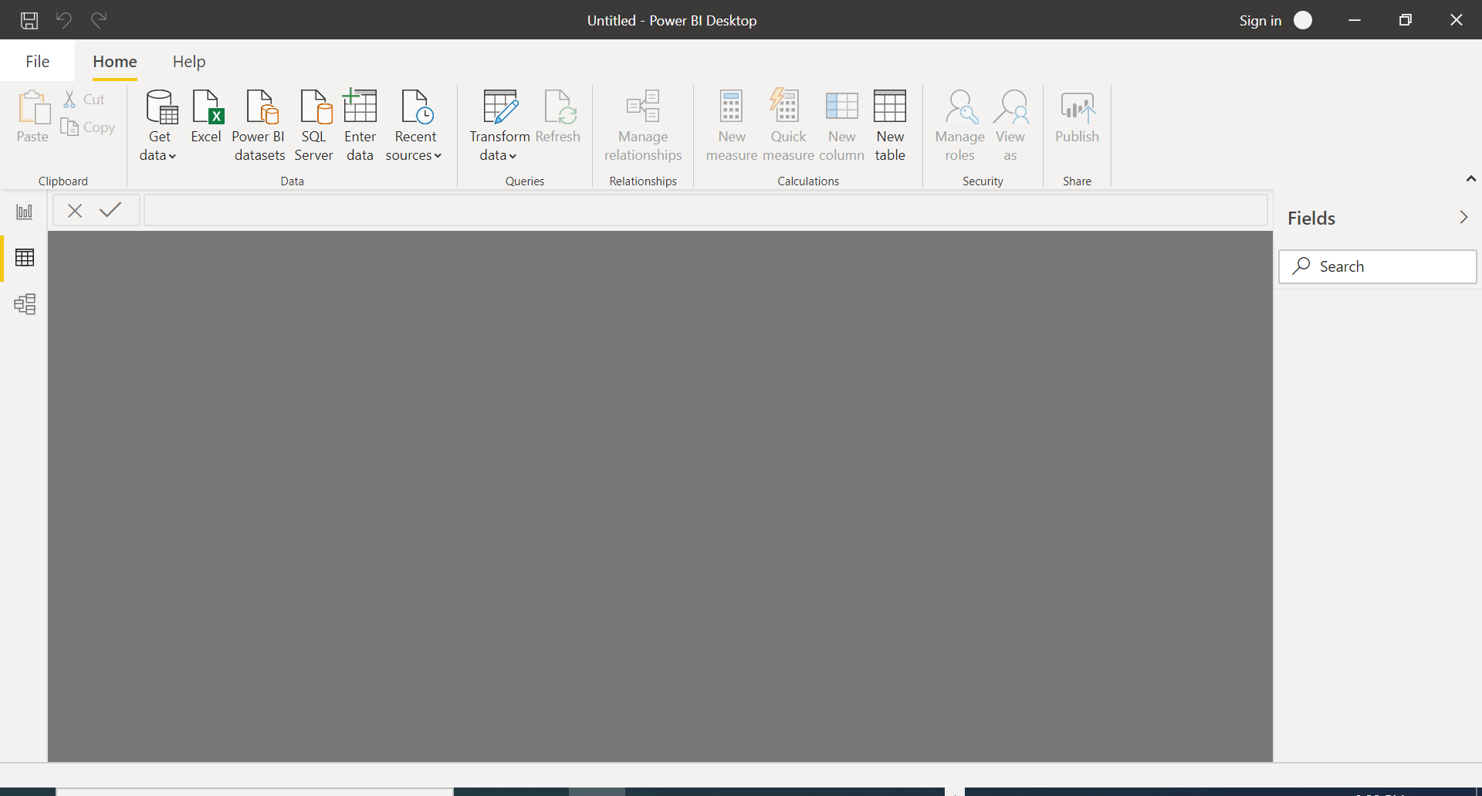

* Model View

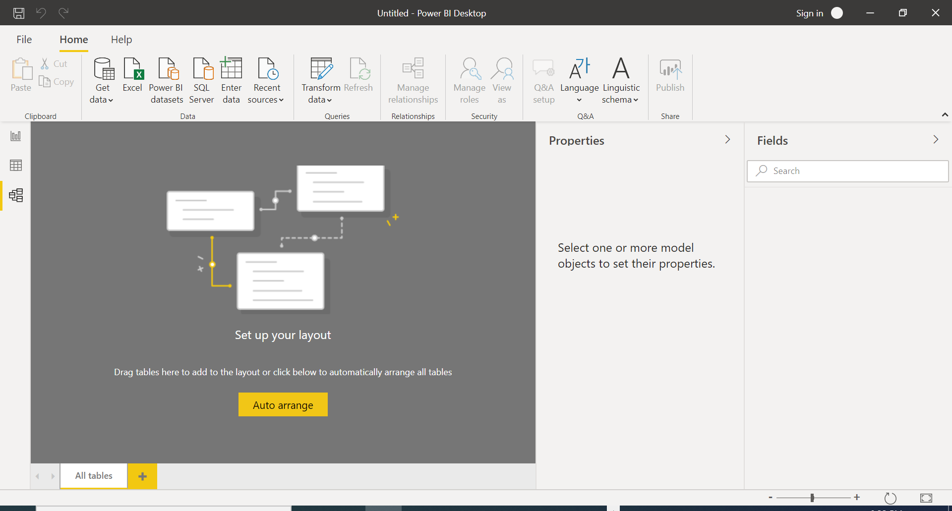

* Power Query Editor

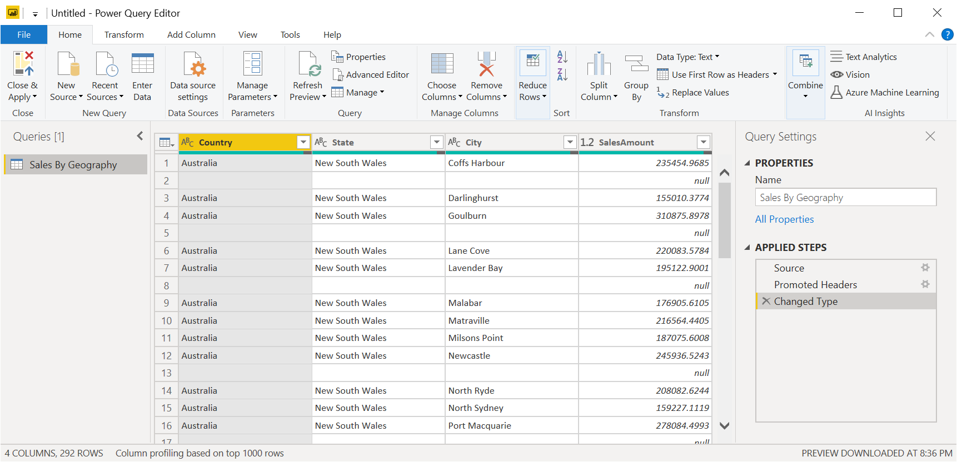

* Advance Editor

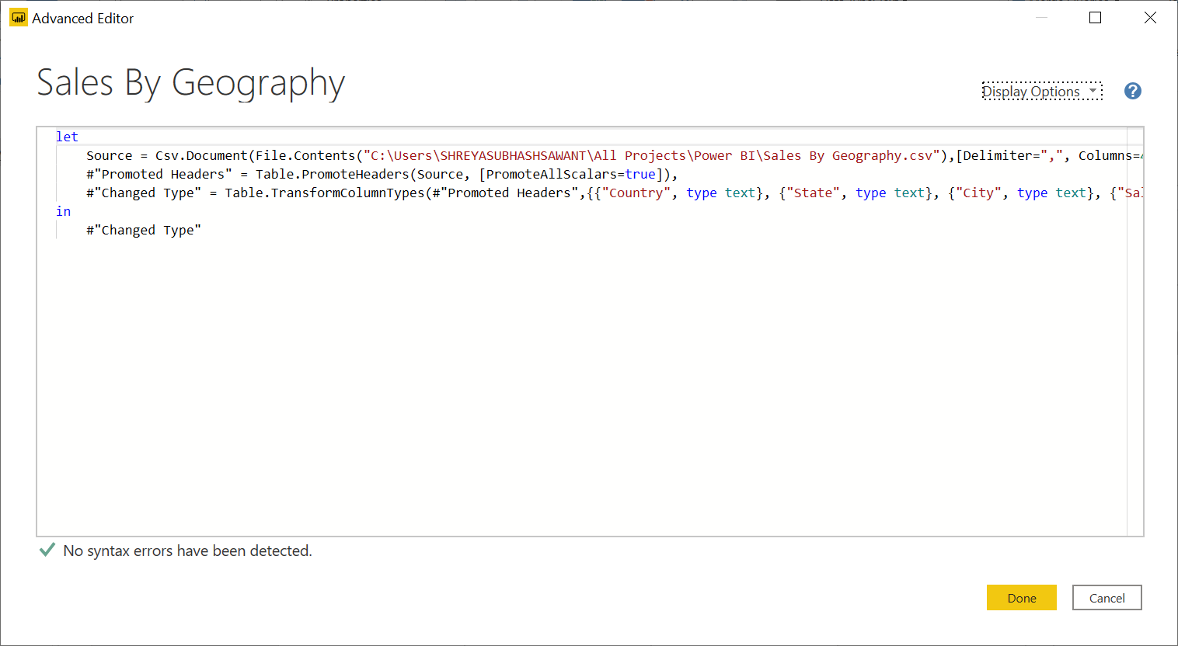

1. Prepare a document with details of the following along with their price:

* Power BI Desktop : Microsoft Power BI is a [business intelligence](https://searchbusinessanalytics.techtarget.com/definition/business-intelligence-BI) platform that provides nontechnical business users with tools for [aggregating](https://whatis.techtarget.com/definition/aggregate), analyzing, visualizing and sharing data. It is a free version of Power BI that is intended for small to midsize businesses.
* Power BI Pro : **Power BI Pro** is an individual user license that lets users read and interact with reports and dashboards that others have published to the **Power BI** service. Users with this license type can share content and collaborate with other **Power BI Pro** users. It costs $9.99/user/month. It includes data collaboration, data governance, building dashboards with a 360-degree real-time view and the ability to publish reports anywhere.
* Power BI Premium: The **Premium** plan starts at $4,995 a month per dedicated cloud compute and storage resource. **Power BI Premium** provides dedicated capacity to deliver more consistent performance and support larger data volumes in **Power BI**. **Power BI Premium** also enables widespread distribution of content by Pro users without requiring users who view the content to have **Power BI** Pro licenses.